Editorial Board

Editor-in-Chief
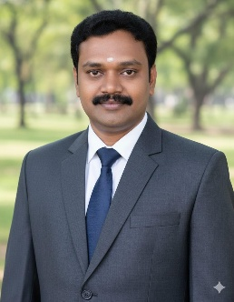
Dr. Karthick B
Assistant Professor
Department of Computer Applications
Government Arts and Science College, Gudalur The Nilgiris
The Nilgiris – 643212, Tamil Nadu, India
karthik@jmrh.in
View Profile https://gascgudalur.in/department-of-computer-application/

Managing Editor
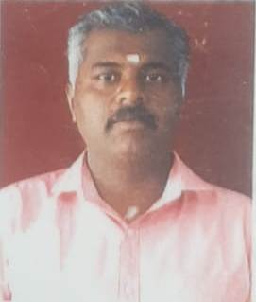
Dr. Sivasankaran M S
Assistant Professor
Department of Commerce with Computer Applications
Government Arts and Science College, Gudalur The Nilgiris
The Nilgiris – 643212, Tamil Nadu, India
sivasankaranms@jmrh.in
https://gascgudalur.in/department-of-commerce-with-ca/

Editorial Board Members
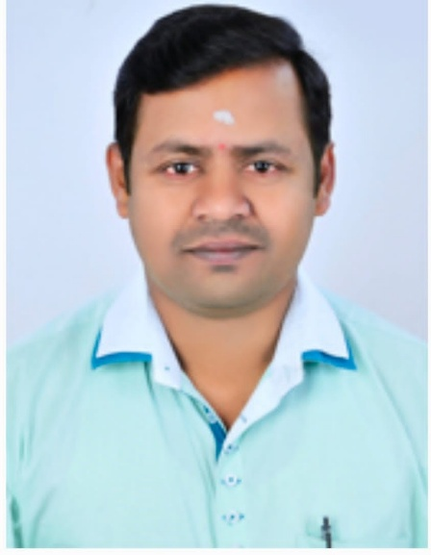
Dr. Jaganathan
Head & Assistant Professor
Department of Commerce with Information Technology
Government Arts and Science College, Gudalur The Nilgiris
jaganathan@jmrh.in
View Profile https://gascgudalur.in/department-of-commerce-with-it/

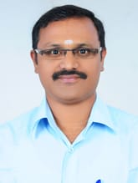
Dr.K.Palanichamy
Head & Assistant professor
Department of Commerce with CA,
Government Arts and Science College, Gudalur, The Nilgiris
palanichamykp@jmrh.in
palanichamykp81@gmail.com
https://gascgudalur.in/department-of-commerce-with-ca/

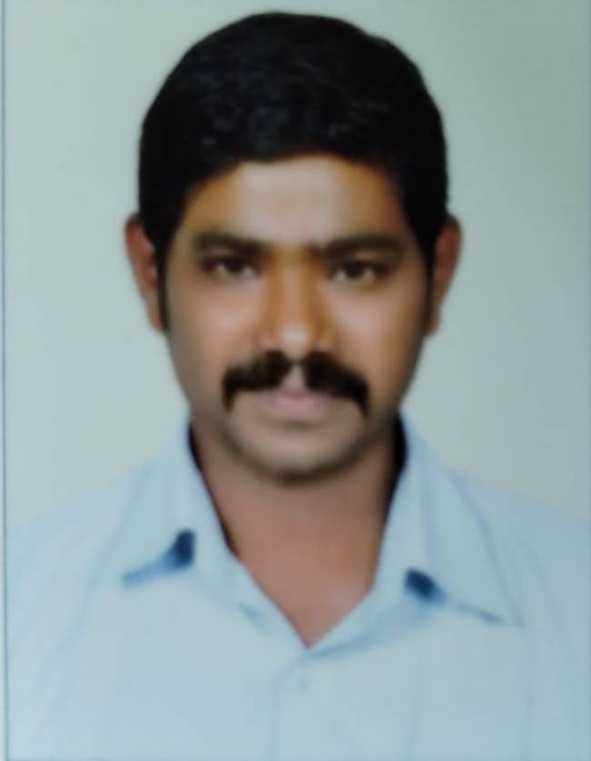
Dr. Porko
Assistant Professor
Department of English
Government Arts and Science College, Gudalur The Nilgiris
porko@jmrh.in
View Profile https://gascgudalur.in/department-of-english/

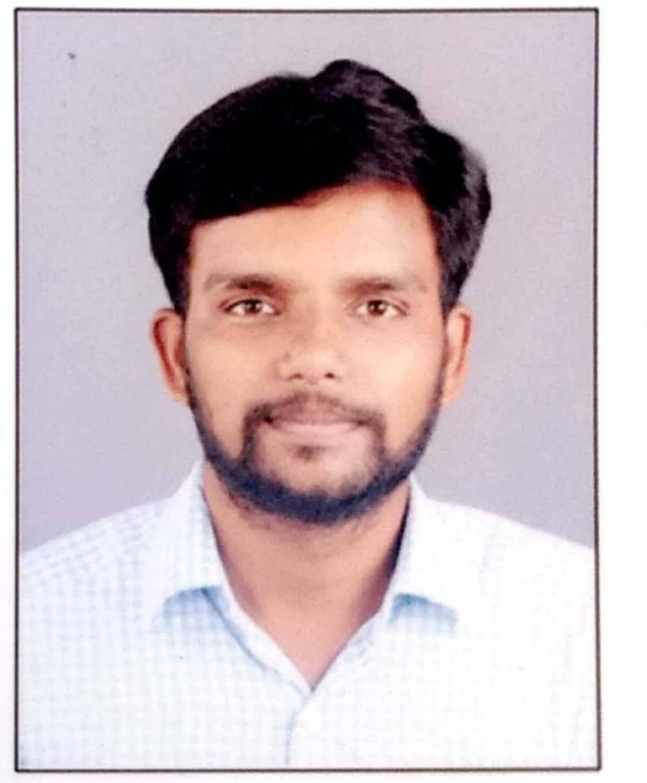
Dr. T. Sathish
Assistant Professor
Department of Mathematics
Government Arts and Science College, Gudalur The Nilgiris
sathisjt@jmrh.in
View Profile https://gascgudalur.in/department-of-mathematics/

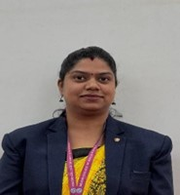
Dr. Dency Mary
Assistant Professor
Department of BBA (IB)
Nilgiri College of Arts and Science (Autonomous), Thaloor The Nilgiris
The Nilgiris – 643240, Tamil Nadu, India
dencymary@nilgiricollege.ac.in
View Profile: https://nilgiricollege.ac.in/faculty/dency.pdf

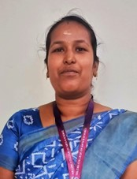
Dr. K Thamarai Selvi
Research Coordinator & Assistant Professor
Department of Commerce
Nilgiri College of Arts and Science (Autonomous)
Konnachal Post, Thaloor, The Nilgiris, Tamil Nadu - 643239
thamaraiselvi@nilgiricollege.ac.in
View Profile: https://nilgiricollege.ac.in/faculty/thamarai

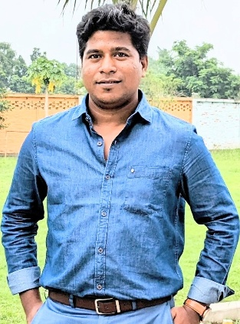
Dr. Sandip Kumar Mukherjee
Associate Professor
Department of Business Administration,
Eminent College of Management and Technology, Barasat, Kolkata 700126
sandip@ecmt.in
https://sites.google.com/ecmt.in/skm

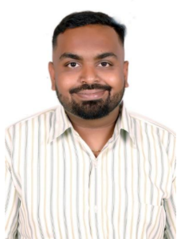
Abhishek BP
Assistant Professor in Language Pathology
AIISH
Centre of Speech Language Sciences, AIISH, Mysuru, Karnataka, India 570006
abhishekbp@aiishmysore.in
https://aiishmysore.in/ka/faculty-members-staff/abhishek-b-p

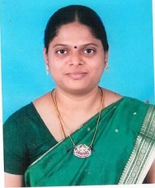

Dr.R.UMAMAGESWARI
ASSOCIATE PROFESSOR
DEPARTMENT OF ELECTRICAL &ELECTRONICS ENGINEERING, ANNAI MIRA COLLEGE OF ENGINEERING & TECHNOLOGY, RANIPET, TAMILNADU,632517
umaamcet2023@gmail.com
https://amcet.in/academics/courses-offered/electrical-and-electronics-engineering/faculty-team/

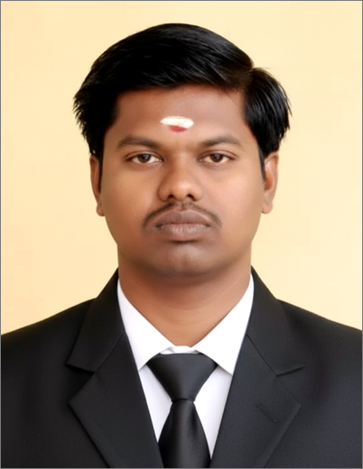

Dr. R.D. Sivakumar
Assistant Professor (Senior Grade) PG Department of Computer Applications
Mepco Schlenk Engineering College, Sivakasi - 626 005. Virudhunagar District, Tamil Nadu, India.
sivakumar@mepcoeng.ac.in
https://www.mepcoeng.ac.in/sivakumarrd

Mail List
- karthik@jmrh.in
- sivasankaranms@jmrh.in
- jaganathan@jmrh.in
- palanichamykp@jmrh.in
- porko@jmrh.in
- sathisjt@jmrh.in

